VENN DIAGRAMS
Pearson Edexcel - Thursday 4 June 2020 - Paper 2 (Calculator) Foundation Tier

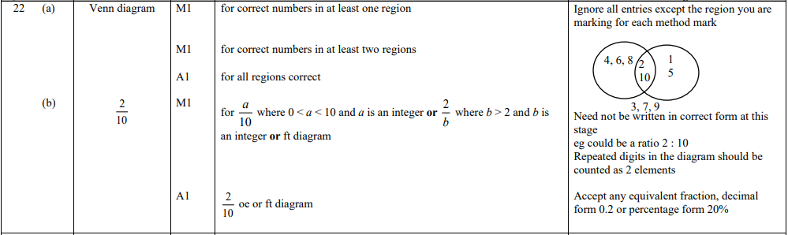

Pearson Edexcel - Tuesday 11 June 2019 - Paper 3 (Calculator) Foundation Tier

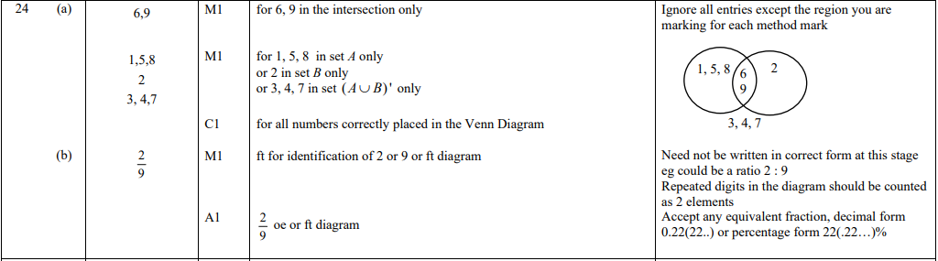

Pearson Edexcel - Thursday 8 November 2018 - Paper 2 (Calculator) Foundation Tier

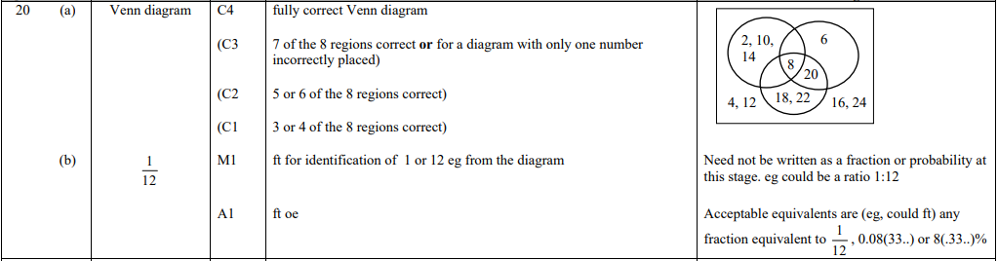

Pearson Edexcel - Thursday 24 May 2018 - Paper 1 (Non-Calculator) Foundation Tier

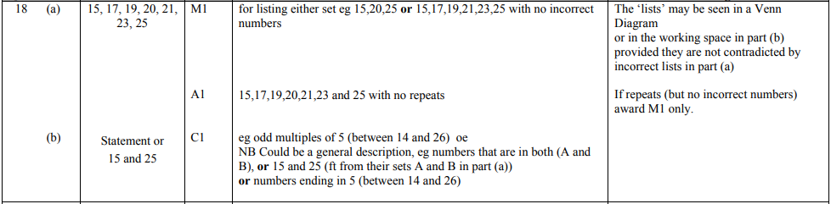

Pearson Edexcel – Specimen 2 - Paper 2 (Calculator) Foundation Tier

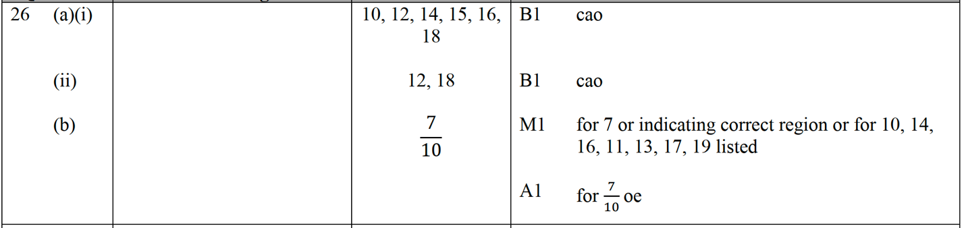

Pearson Edexcel – Specimen 1 - Paper 3 (Calculator) Foundation Tier

OCR – Tuesday 03 November 2020- Morning - Paper 1 (Calculator) Foundation Tier
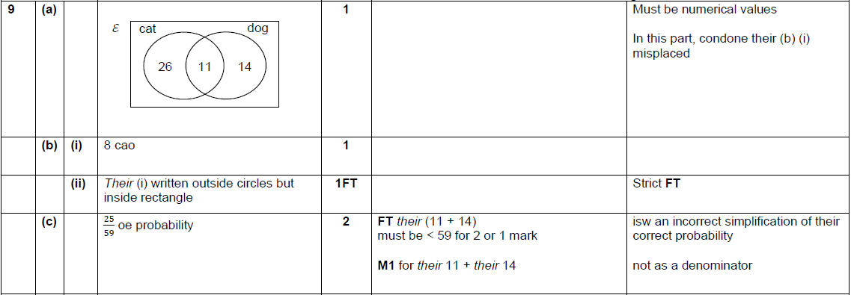

OCR Thursday 07 November 2019- Morning (Non-Calculator) Foundation Tier
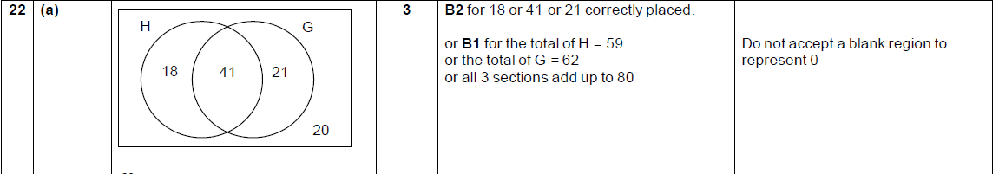

OCR Tuesday 21 May 2019 – Morning (Calculator) Foundation Tier

OCR Tuesday 6 November 2018 – Morning (Calculator) Foundation Tier
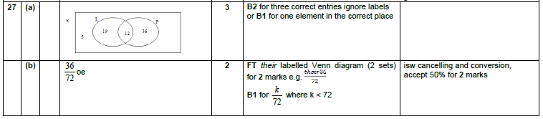

OCR Thursday 7 June 2018 – Morning (Non Calculator) Foundation Tier
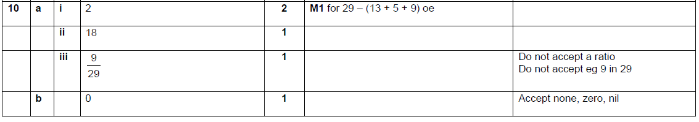

OCR Sample Question Paper 1 – Morning/Afternoon (Calculator) Foundation Tier

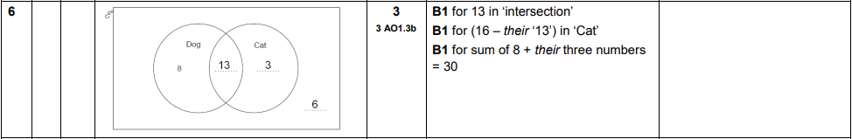

AQA Tuesday 19 May 2020 – Morning (Non-Calculator) Foundation Tier

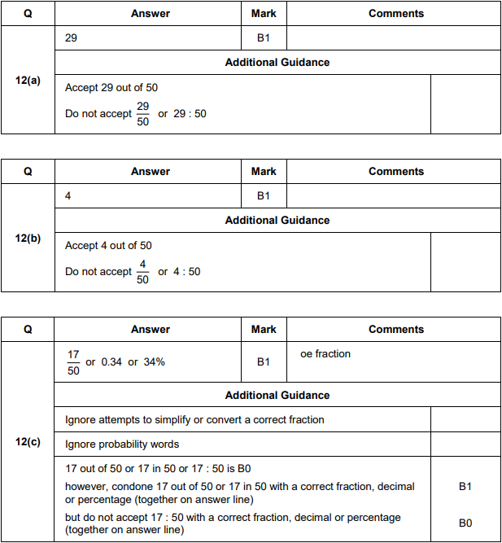

AQA Thursday 6 June 2019 – Morning (Calculator) Foundation Tier

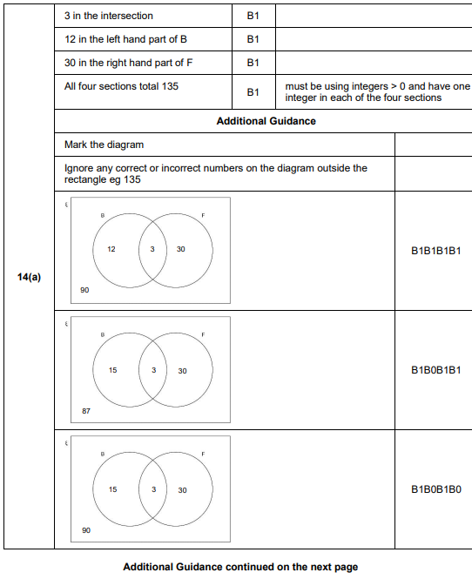
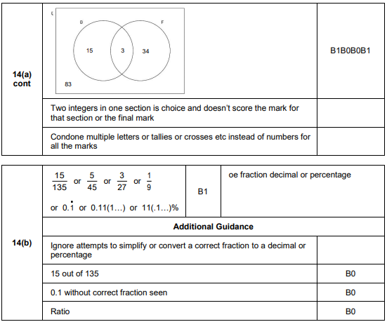
AQA Tuesday 6 November 2018 – Morning (Non-Calculator) Foundation Tier

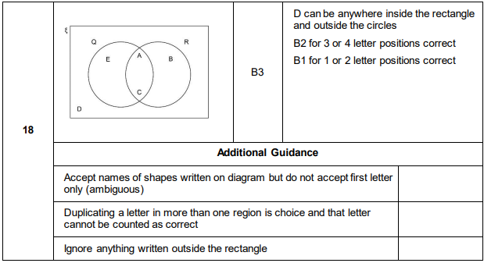
AQA Tuesday 12 June 2018 – Morning (Calculator) Foundation Tier

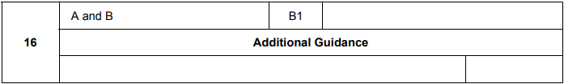

AQA Tuesday 12 June 2018 – Morning (Calculator) Foundation Tier

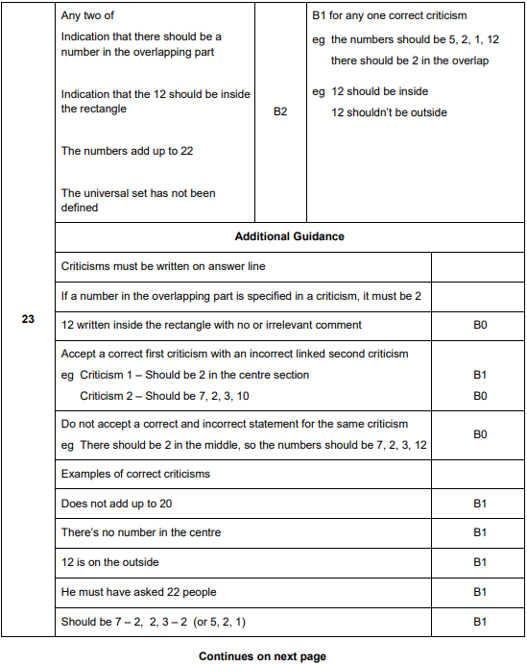
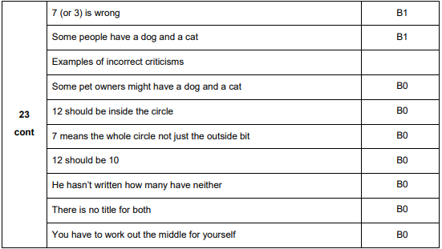
AQA Wednesday 8 November 2017 – Morning (Calculator) Foundation Tier

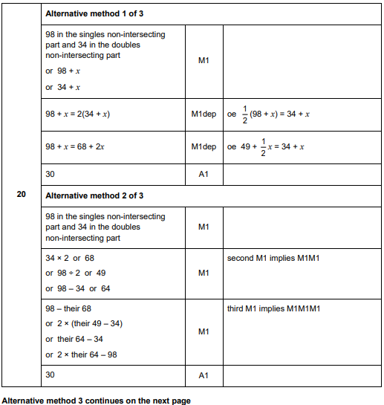
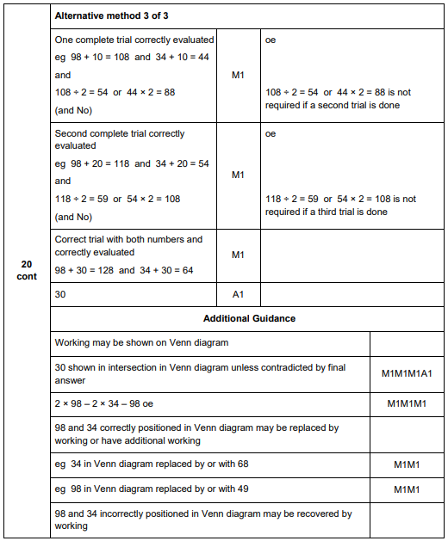

AQA Sample Paper 2– Morning (Calculator) Foundation Tier

